Assignment – 4
Data Analytics, LIET College

- Write an SQL query to display the names and salaries of employees whose salary is greater than the average salary in the company. Explain how the subquery works.
Ans.
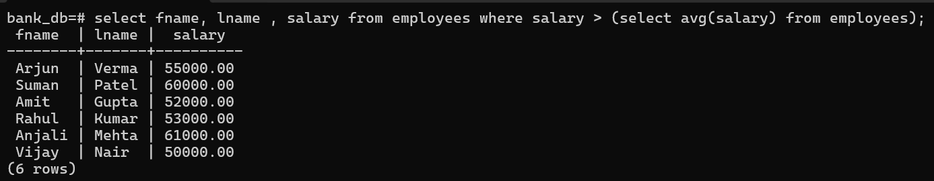
A subquery is a query written inside another SQL query and is executed first. The result obtained from the subquery is then used by the outer query to perform further operations.

- Write a query to retrieve the top 5 highest-paid employees from an employees table. Explain how sorting affects the output.
Ans.
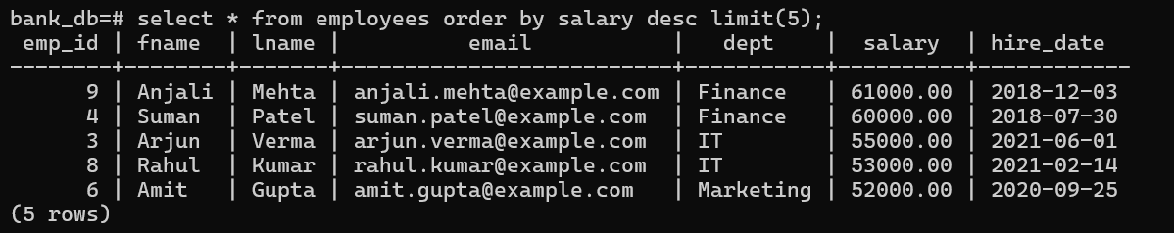
Sorting in SQL is performed using the ORDER BY clause, which arranges the data in a specific order (ascending or descending).
- Write a query to calculate:
• Total number of employees
• Average salary
• Minimum and maximum salary
Explain the difference between aggregate and scalar functions.
Ans.
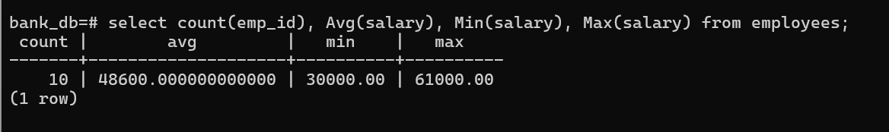
Aggregate functions summarize multiple rows into one result, whereas scalar functions perform operations on individual values without combining rows.

- Given a sales table with columns (region, amount), write a query to find total sales per region. Filter only those regions where total sales exceed 50,000
Ans.
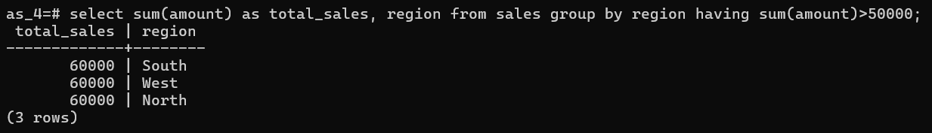

- Write a query to find the number of unique job roles in an employees table. Explain why DISTINCT is necessary here.
Ans.
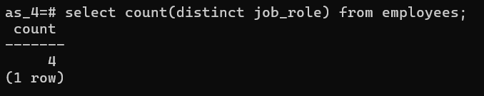
The DISTINCT keyword is used to eliminate duplicate values from a column and return only unique entries.
- Write a query to retrieve students who scored between 60 and 80
marks. Rewrite the same query using BETWEEN.
Ans.
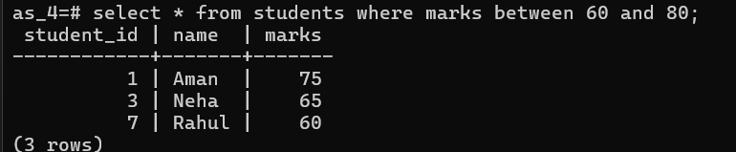

- Write a query to display employees whose commission is NULL. Explain the correct way to check NULL values in SQL.
Ans.
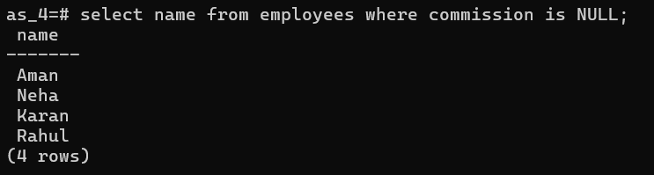
In SQL, NULL represents the absence of a value, and it cannot be compared using standard comparison operators such as = . To check for NULL values, the IS NULL or IS NOT NULL operators must be used.
- Write a query to increase the salary of employees in the “IT” department by 10%. Explain how arithmetic operations are handled in SQL.
Ans.
Arithmetic operations in SQL are performed using standard mathematical operators such as + (addition), - (subtraction), * (multiplication), and / (division). These operations can be applied directly within SQL queries, especially in SELECT and UPDATE statements, and are evaluated for each row individually.
- Write a query to delete records of students who scored less than 40 marks. What precaution should be taken before executing DELETE?
Ans.

Before executing a DELETE statement, it is important to ensure that the correct records are being targeted, as the operation permanently removes data from the table.
A common precaution is to first run a SELECT query with the same condition to verify which rows will be deleted.

- Write a query to find employees who earn more than the average salary of their department (without using joins). Explain the logic of the subquery
Ans.
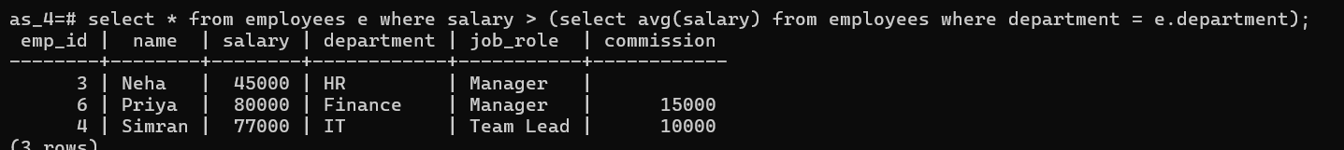
The outer query then compares each employee’s salary with the average salary of their respective department and selects only those employees whose salary is higher than that average.
Thus, the subquery dynamically provides department-wise average values, enabling row-by-row comparison in the main query.

Submitted By: Tushar Saini

